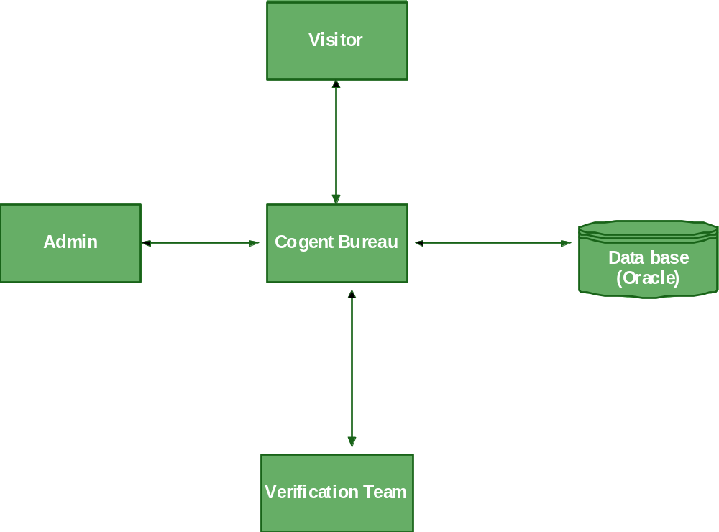

Level 0 DFD for Admin
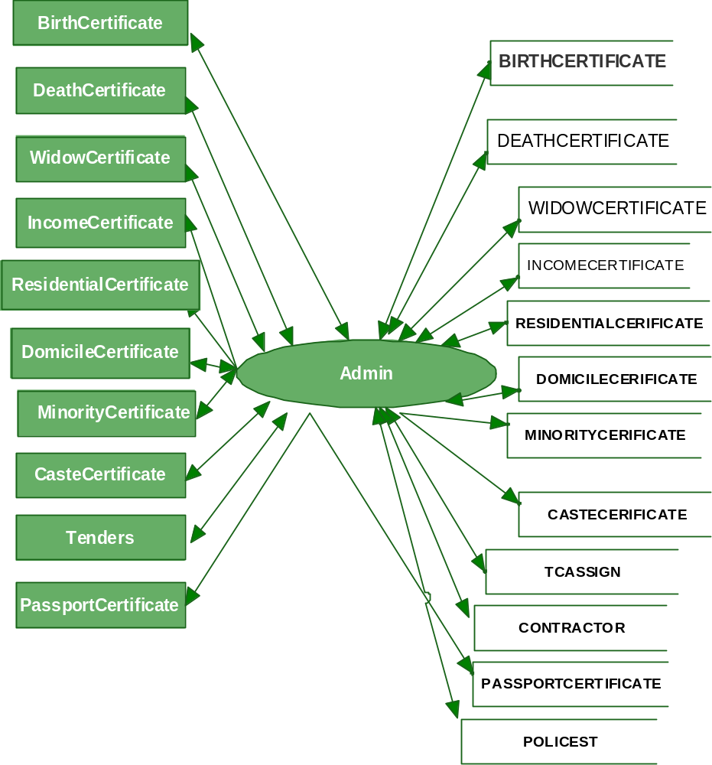
Level 1DFD For Birth.Death,Widow Certificates

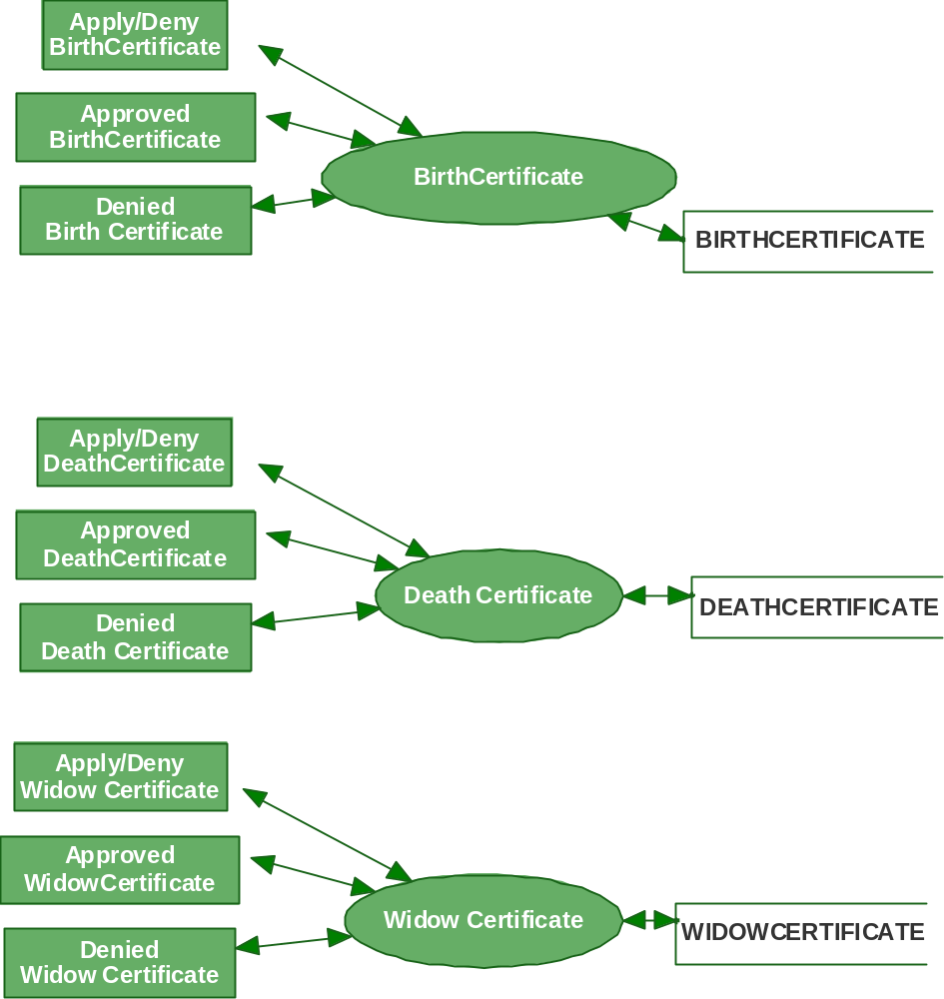
Level 1DFD For Income,Residential,Domicile Certificates

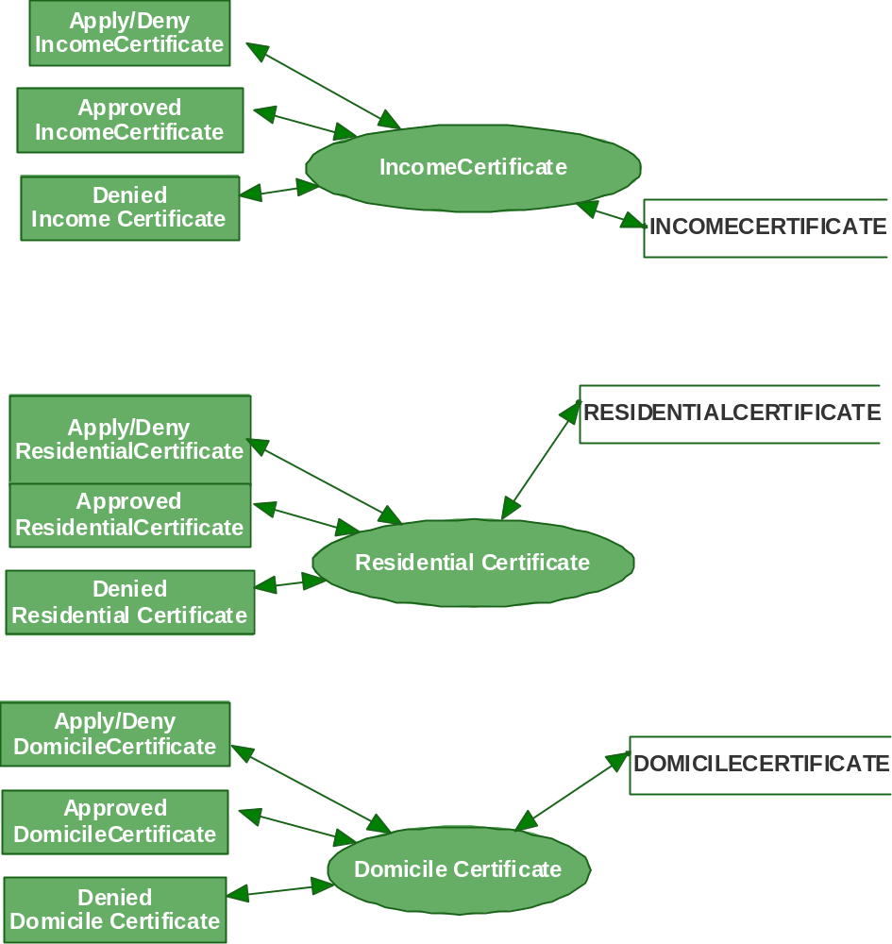

Level 1 DFD For Minority Certificate

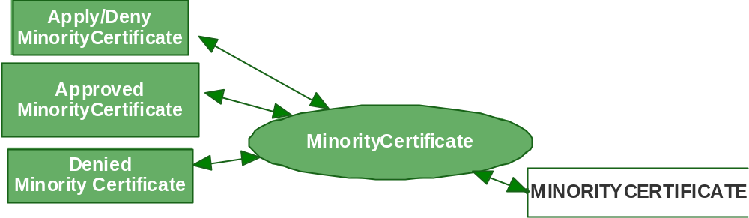

Level 1 DFD For Passport Certificate

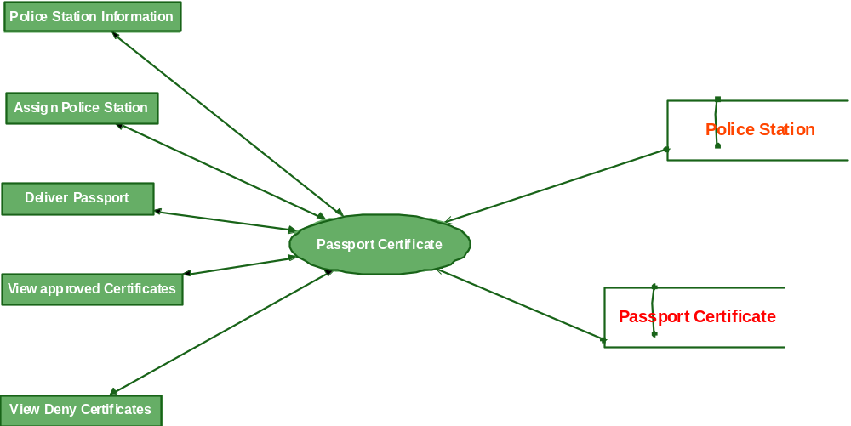

Level2 DFD for Police Station Information

Level1 For Tenders:

